Section 2: Data Structures
Identifying structures from Java code, Big-O complexity, trees, linked lists, stacks/queues, and more
Q23 | 2020 (COVID - single packet)
Once a method has correctly implemented a binary search algorithm, which of these would represent the tightest correct runtime
on an array of n elements?
A) O(n2
B) O(n
C) O(1
D) O(log n
E) O(n log n

Q37 | 2020 (COVID - single packet)
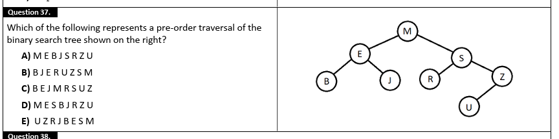

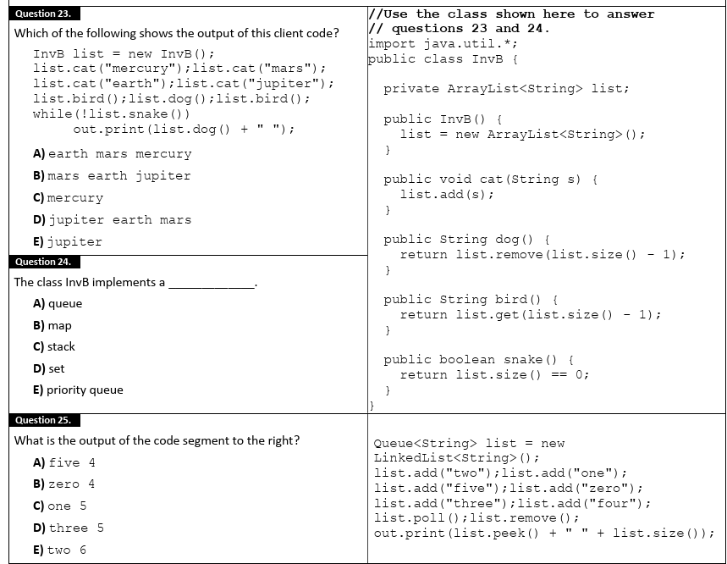
Q29 | 2020 (COVID - single packet)
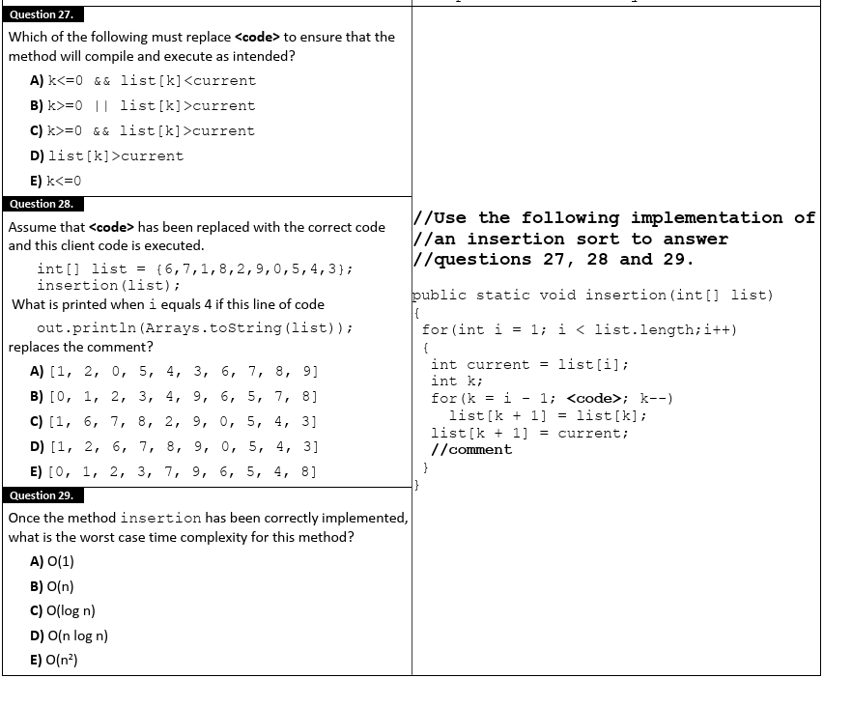

Q40 | 2020 (COVID - single packet)
If the values shown here are placed into a binary search tree in the order that they are listed, which value will serve as the root
node? Write your answer in the blank provided on the answer document.
2 0 8 4 6 7 1 3 5 9

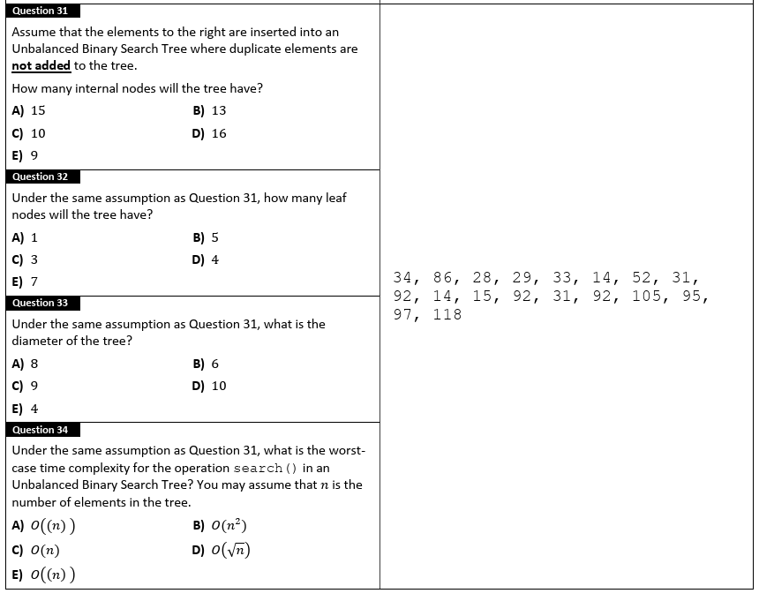Q35 | 2025 Invitational A
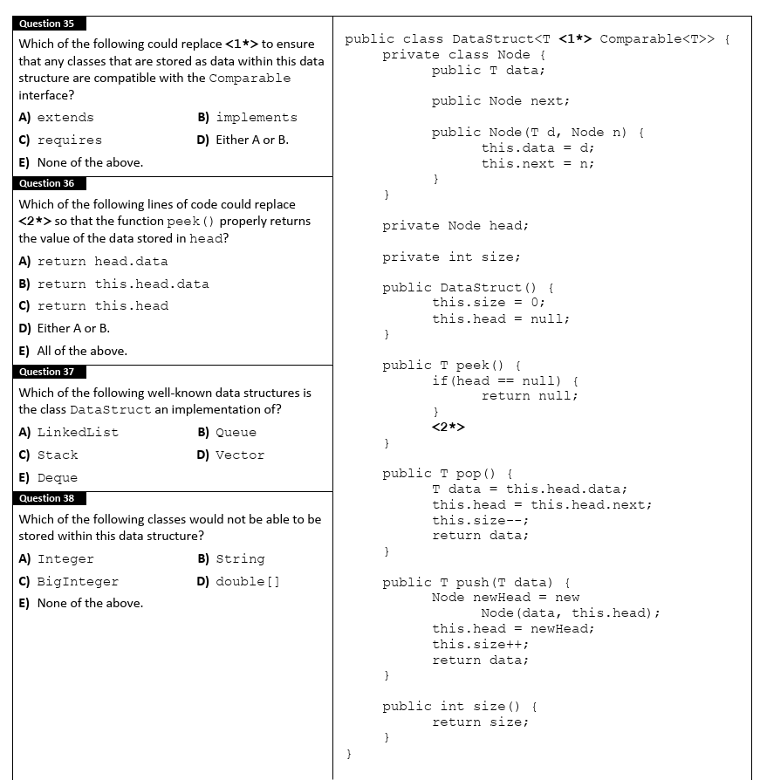
Q40 | 2025 Invitational B
What is the in-order traversal of the binary search tree created by inserting the following values in order?
34 67 212 17 9 6 104 8 29 48 97 147 1

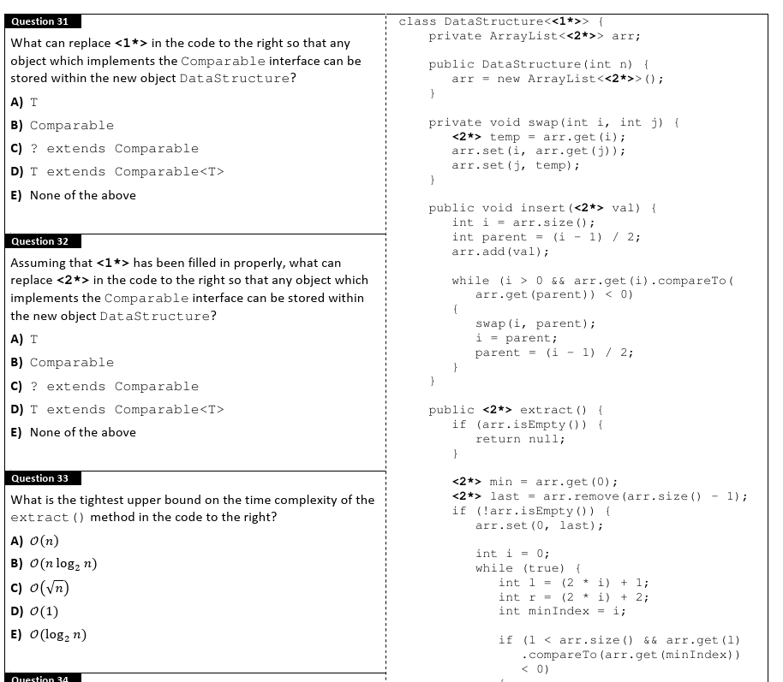
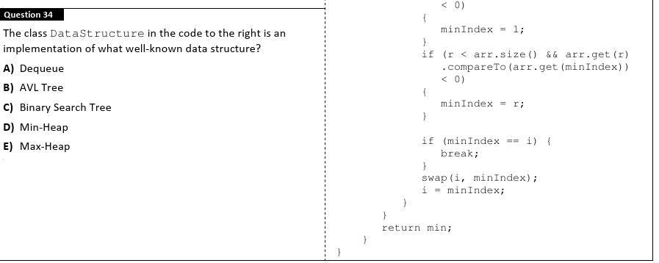

Q35-38 | 2025 Region

Q18-19 | 2025 State
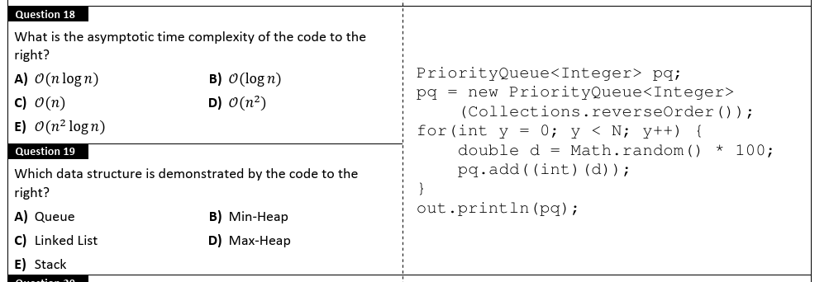
Q24 | 2025 State
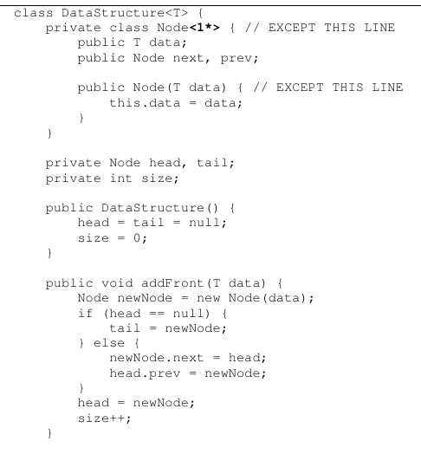
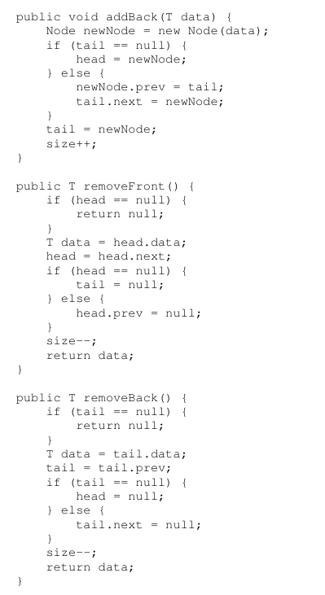

24. The class DataStructure in the code to the right is a partial
implementation of what well-known data structure?
A) Dequeue
B) AVL Tree
C) Stack
D) Min-Heap
E) Queue

Q36 | 2024 Invitational A
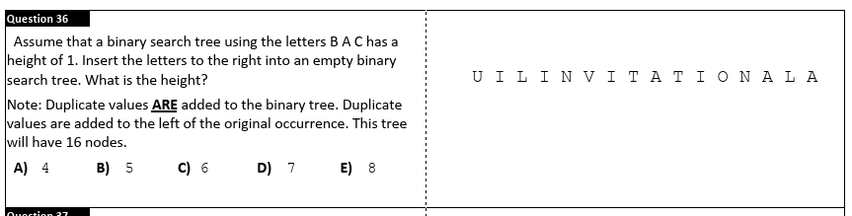
Q32 | 2024 Invitational B
How many levels?
A) 8
B) 10
C) 11
D) 12
E) 1999
In a Binary Search Tree consisting of 2000 nodes. What
is the minimum number of levels the tree may have?
Example: An initially empty Binary Search Tree adding
the elements B, then A, then C would have 2 levels.

Q39 | 2024 District
Imagine you have an empty binary search tree. First, you add
the five vowels into the tree, one at a time in this order
(A,E,I,O,U). Next, you add to the tree the remaining consonants
in alphabetical order, starting with B and ending with Z.
How many leafs would the tree have?
Write the number in blank #39.

Q40 | 2024 State
Create a binary search tree inserting the letters "AUSTIN".
Start with A and end with N. How many leaves will the tree
have? Write your answer in blank #40.

Q36 | 2023 Invitational A
If the letters to the right were inserted into an initially empty
binary search tree in the order shown, how many leaves would the
resulting tree contain?
A) 9
B) 10
C) 12
D) 1
E) 19
A B C D E F G H I J J I H G F E D C B A

Q40 | 2023 District
Create the binary search tree using the letters in the word to the
right. After building the tree, determine how many leaf nodes the
tree contains.
T R A M P O L I N E

Q40 | 2023 Region
Consider a binary tree with 1023 nodes. What is the greatest
number of leaves that the tree could contain?

Q21 | 2022 Invitational A
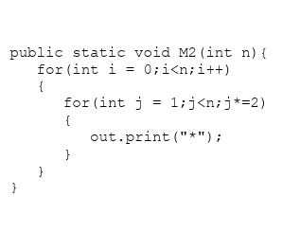
What is the tightest upper bound for the Big O complexity of M2?
A) O (n
B) O (nlogn
C) O (n2
D) O (2n
E) none of the above

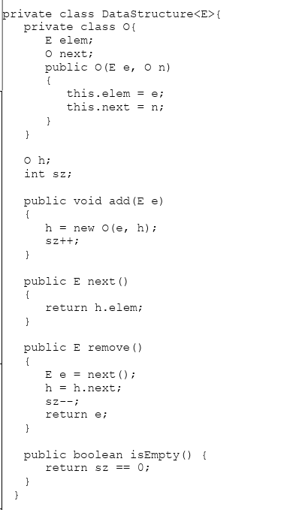
Q29 | 2022 Invitational A
What data structure does DataStructure represent?
A) Queue
B) PriorityQueue
C) Stack
D) Set
E) none of the above

Q18 | 2022 Invitational B
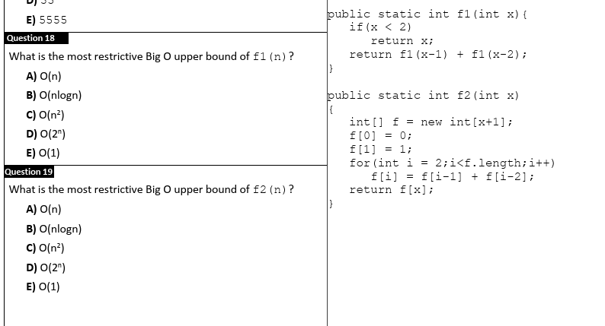Q29 | 2022 Invitational B
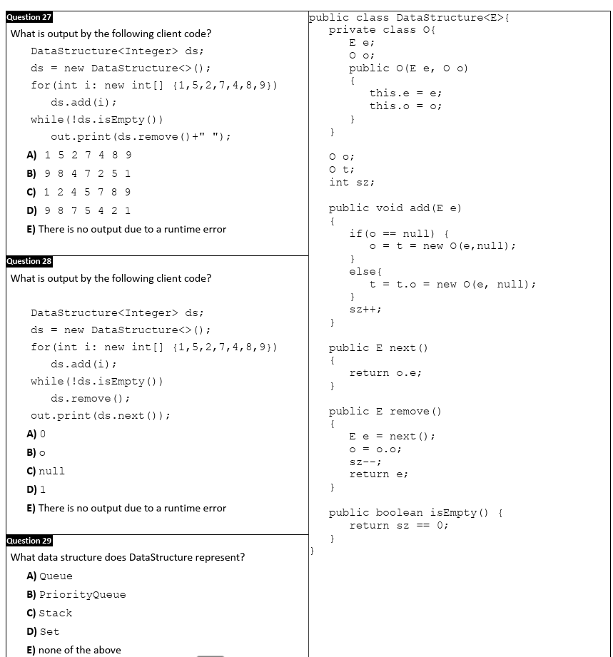Q23 | 2022 District
Question 24.
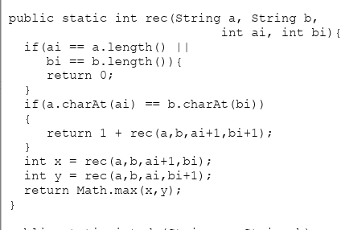
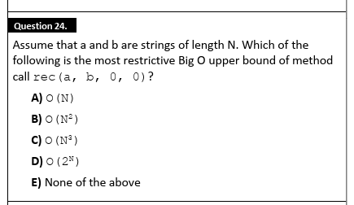Q25 | 2022 District

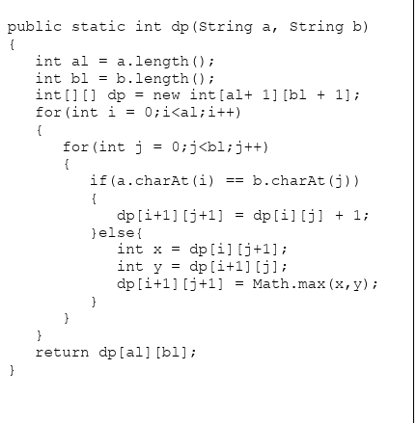

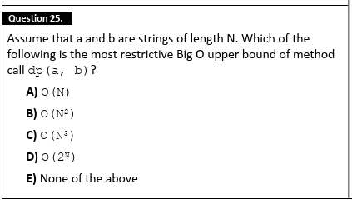
Q34 | 2022 District
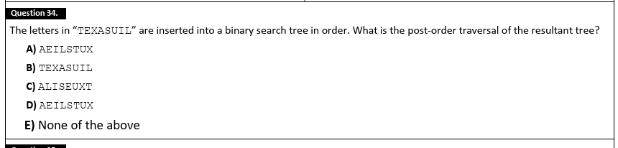
Q37 | 2022 District
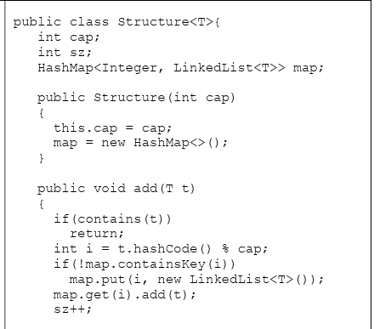
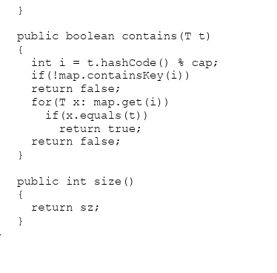
37.
Which of the following is the most restrictive Big O upper bound
of method add?
A) O(1
B) O(log(N
C) O(N
D) O(N2
E) None of the above
}

Q38 | 2022 District
What data structure does the Structure class represent?
A) Map
B) HashMap
C) Queue
D) ArrayList
E) HashSet

Q40 | 2022 District
If a binary tree contains 12 nodes, what is the most number of levels (including the root) that tree might have? Write your answer
in the blank provided on the answer document.

2022 Region
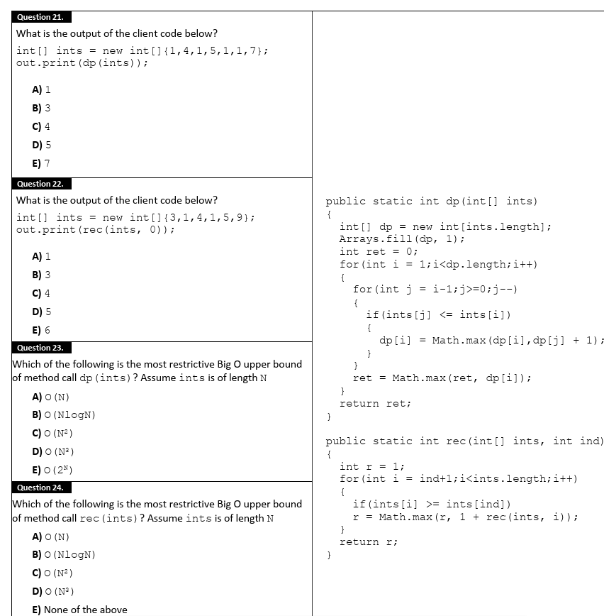
Q29 | 2022 Region
What is the worst case time complexity of add() for Java’s PriorityQueue? Assume comparison is an O(1) operation.
A) O(1
B) O(log(N
C) O(N
D) O(NlogN
E) O(N2

Q31 | 2022 Region
What is the best case time complexity of bubble sort?
A) O(1
B) O(N
C) O(NlogN
D) O(N^2
E) None of the above

Q35 | 2022 Region
The letters “DBFCAGE” are inserted into a binary search tree in order. Which of the following traversals will result in a visitation
order of DBFACEG?
A) Pre-order traversal
B) Post-order traversal
C) In-order traversal
D) Level-order traversal
E) None of the above

Q17 | 2022 State
What is the worst case Big O Complexity of java.util.PriorityQueue remove() method? Assume comparison is an O(1)
operation.
A) O(1
B) O(log(N
C) O(N
D) O(Nlog(N
E) O(N2

Q40 | 2021 Invitational A
Write the signed 8-bit binary two's complement representation of -104 in the blank provided on the answer document.

| 2021 Invitational B
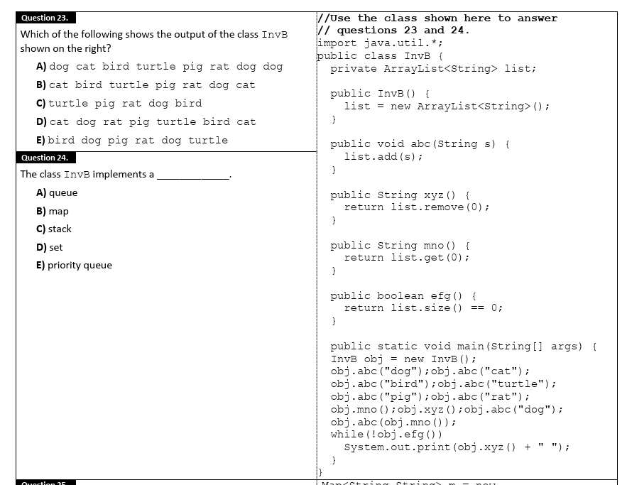

Q: 27-29 | 2021 Invitational B
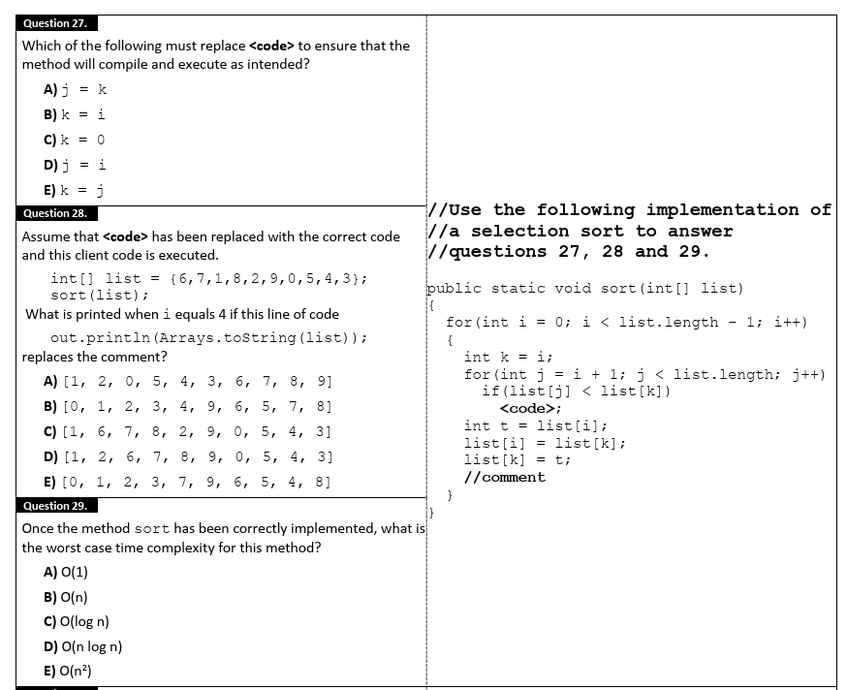

Q32 | 2021 Invitational B
What is the average time complexity for insertion into a somewhat balanced binary search tree?
A) O(n
B) O(2n
C) O(n^2)
D) O(log n)
E) O(n log n)

Q36 | 2021 Invitational B
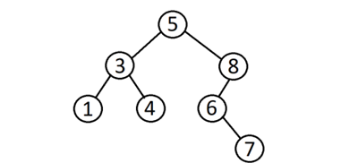
Which of the following represents a post order traversal of the
binary search tree shown on the right?
A) 7 1 4 6 3 8 5
B) 1 3 4 5 6 7 8
C) 5 3 1 4 8 6 7
D) 1 4 3 7 6 8 5
E) 5 3 8 1 4 6 7

Q37 | 2021 District 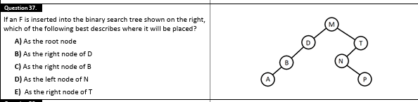
Q40 | 2021 District
If a binary tree contains 255 nodes, what is the least number of levels (including the root) that tree might have?
Q37 | 2021 Region
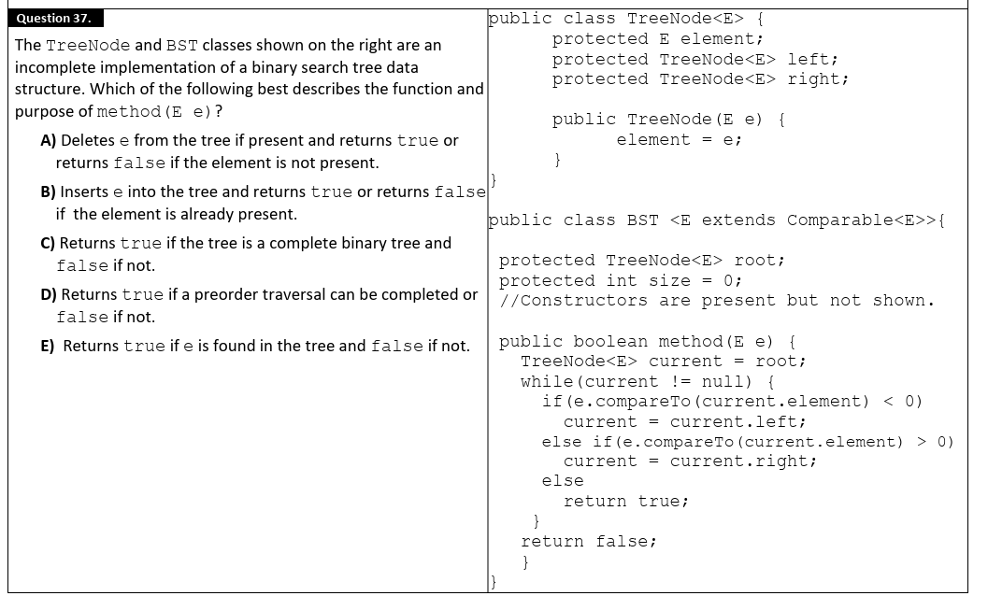Q40 | 2021 Region
What is the worst case time complexity for access to an element within an array. Write your answer using Big-O notation in the
blank provided on the answer document.

Q24 | 2019 Invitational A
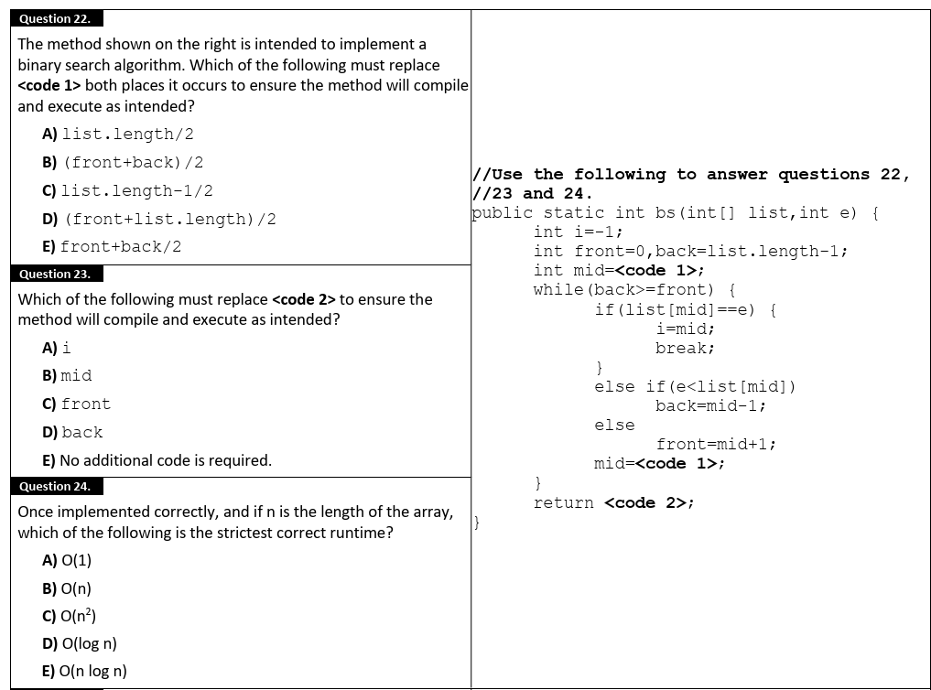Q36 | 2019 Invitational A
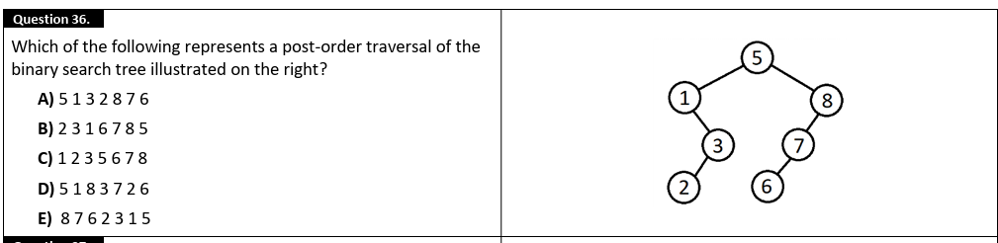
Q26-29 | 2019 Invitational B
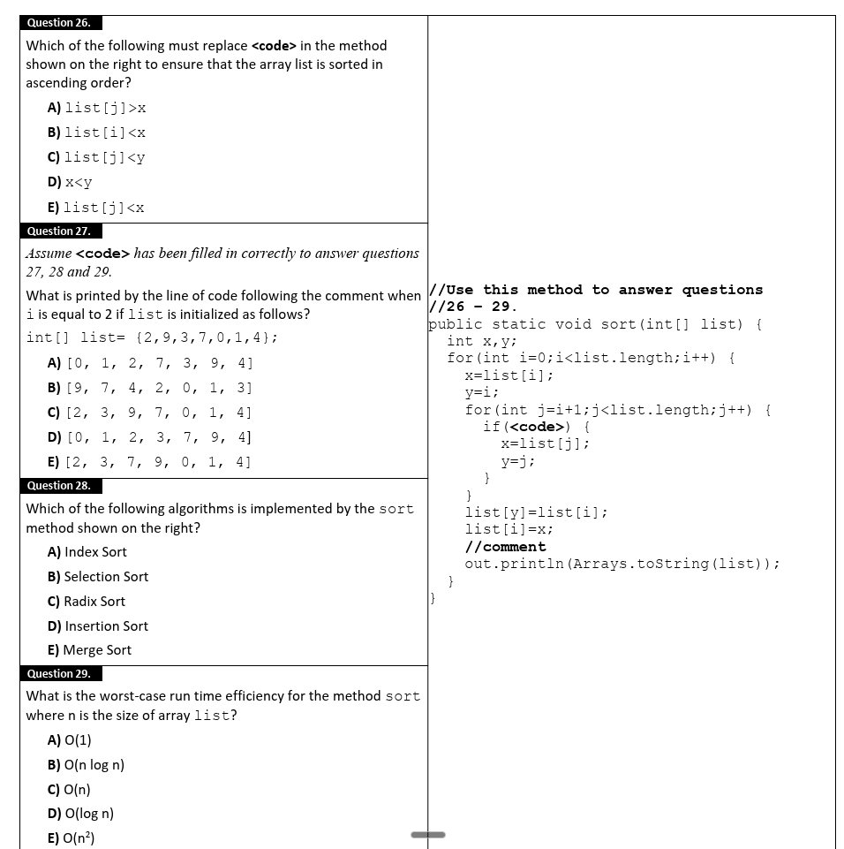

Q36-37 | 2019 Invitational B
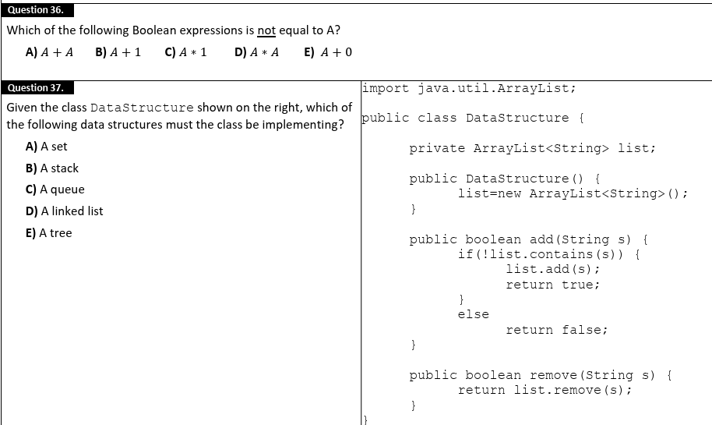

Q40 | 2019 Invitational B
How many leaves are contained within a binary search tree that is constructed by inserting the following values in the order
shown?
58 19 18 3 4 1 67 60 82
Q25 | 2019 District
What is the run time complexity (Big O value) for an ascending insertion sort of an array that contains n elements if the array is
already sorted in ascending order?
A) O(1)
B) O(n)
C) O(n2)
D) O(log n)
E) O(n log n)

Q32 | 2019 Region
Which of the following run time efficiencies is the fastest for very large values of n?
A) O(n log n
B) O(log n
C) O(n)
D) O(n^2)
E) O(2n)

Q33 | 2019 State
What is the worst case relative run time efficiency (complexity) of a Merge sort ?
A) O(n)
B) O(n^2)
C) O(log n)
D) O(n log n)
E) O(n^3)

Q34 | 2018 Invitational A
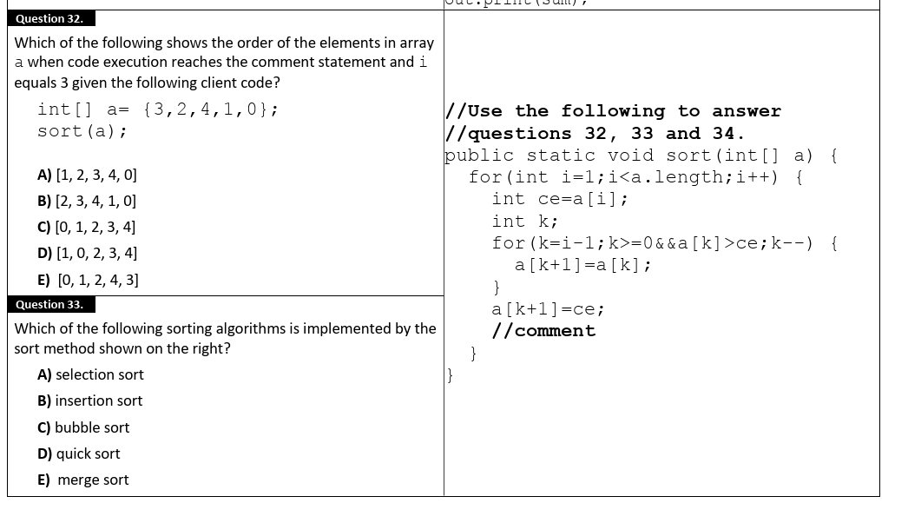
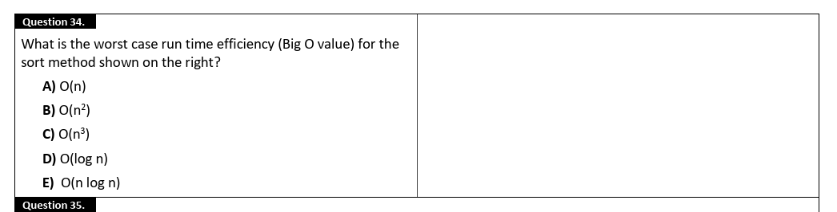
Q38 | 2018 Invitational A
What is the worst case time complexity for accessing an element in a linked list?
A) O(1)
B) O(log n)
C) O(n) D) O(n^2) E) O(n log n)

Q23-27 | 2018 Invitational B
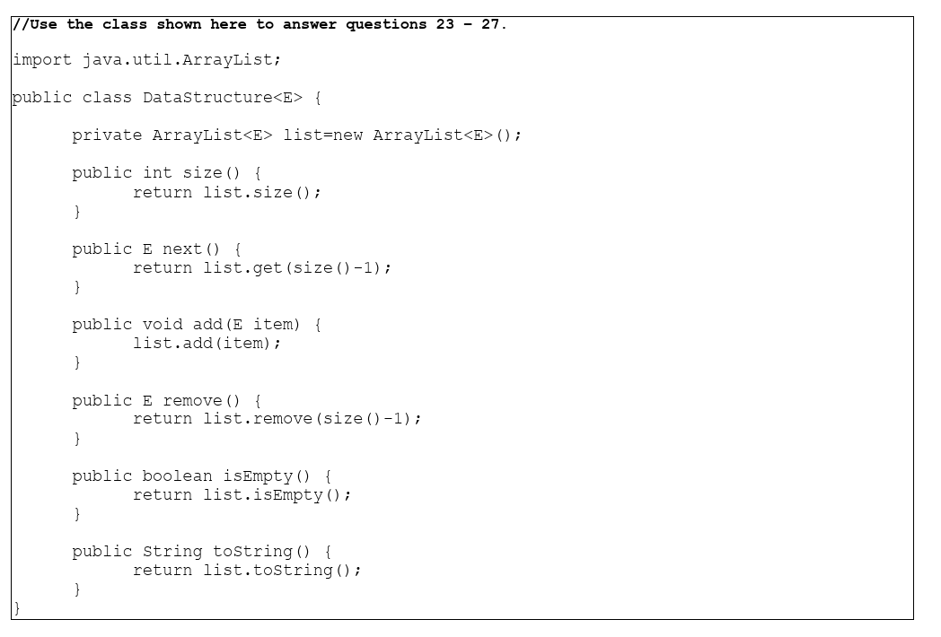
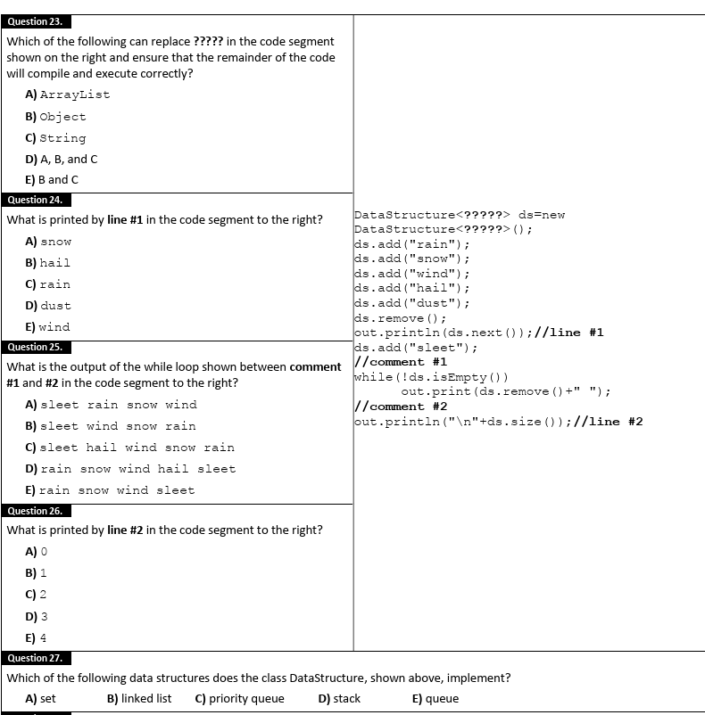
Which of the following data structures does the class DataStructure, shown above, implement?
A) set
B) linked list
C) priority queue
D) stack
E) queue

Q37 | 2018 Invitational B
Each element within a linked list data structure is stored within a _____________?
A) array
B) edge
C) identifier
D) class
E) node

Q27-29 | 2018 District
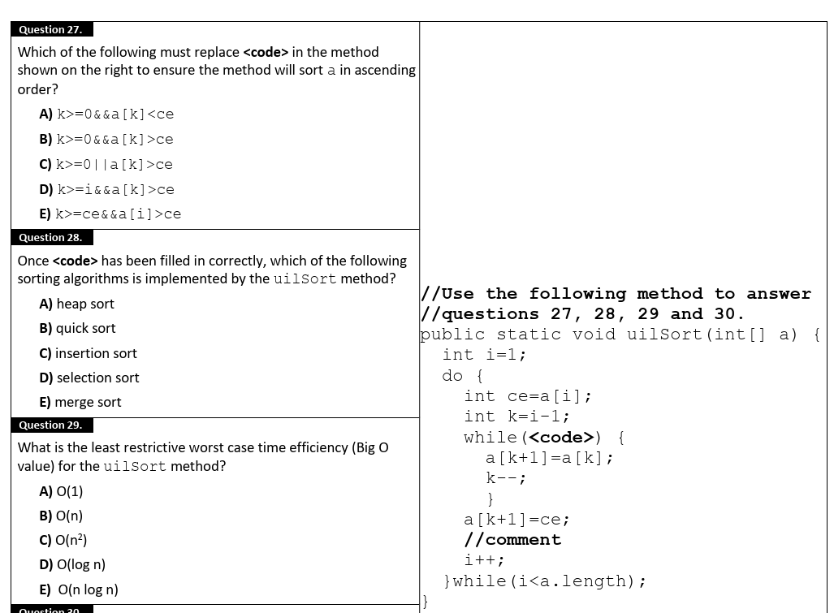

Data Structures
2020 (COVID - single packet)
Q23: D Q37: A
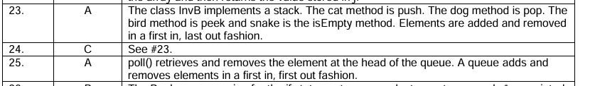
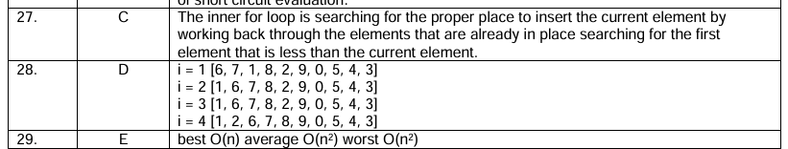
Q40: 2

2025 Invitational A
Q31: E
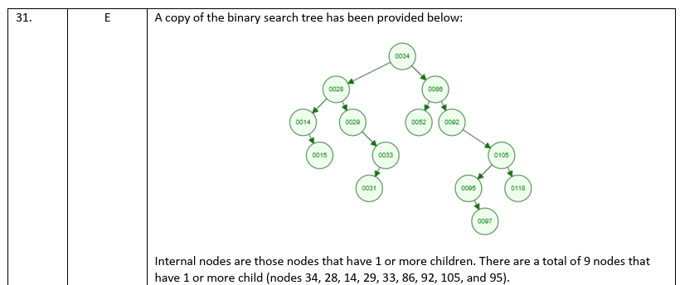

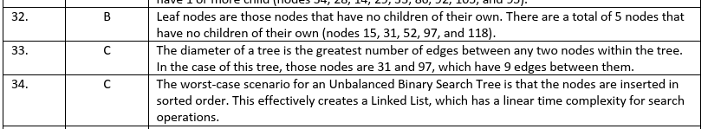
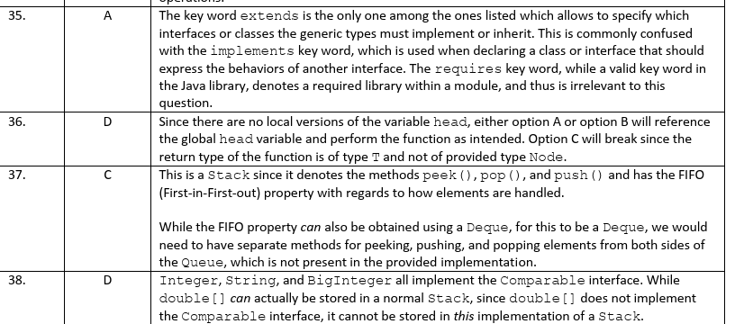2025 Invitational B
2025 Region
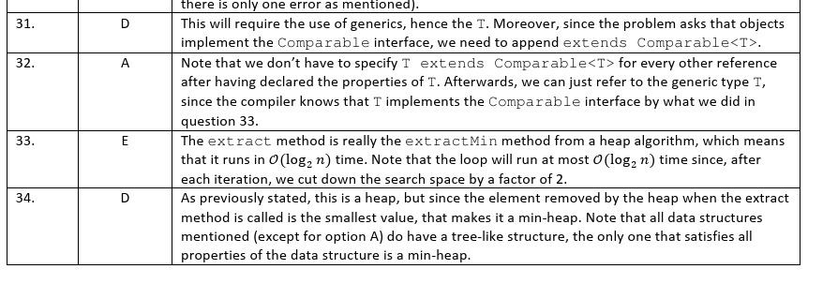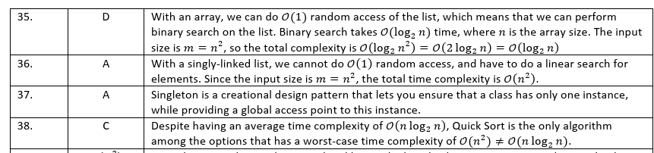
2025 State
Q24: A
2024 Invitational A
Q36: C
2024 Invitational B
Q32: C
2024 District
Q39: 5
2024 State
Q40: 2
2023 Invitational A
Q36: B
2023 District
Q40: 2
2023 Region
Q40: 512
2022 Invitational A
Q21: B Q29: C
2022 Invitational B
Q18: D
2022 District
Q23: C
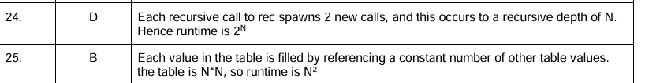 Q34: C
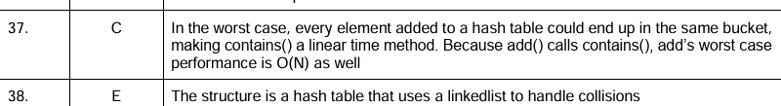 Q40: 12
2022 Region
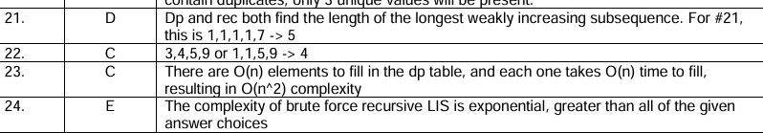
Q29:B Q31: B Q35: D
2022 State
Q17: B
2021 Invitational A
Q40: 10011000
2021 Invitational B
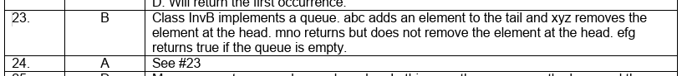
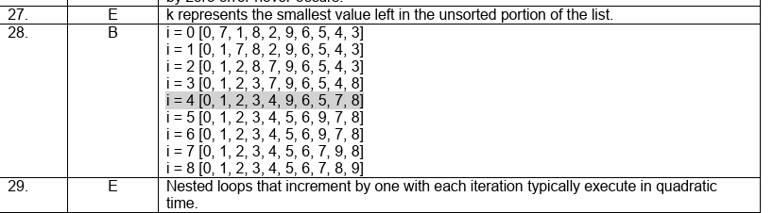 Q32: D Q36: D
2021 District
Q37: b Q40: 2021 Region
Q37: E Q40: O(1)
2019 Invitational A
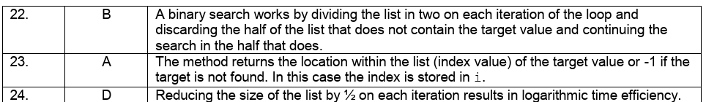Q36: B
2019 Invitational B
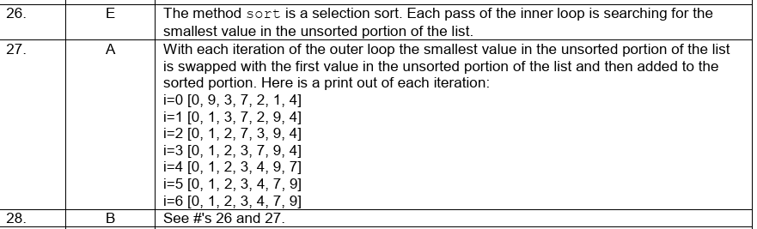 Q40: 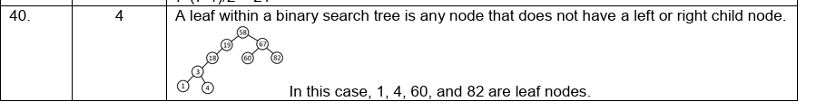
2019 District
Q25: B
2019 Region
Q32: B
2019 State
Q33: D
2018 Invitational A
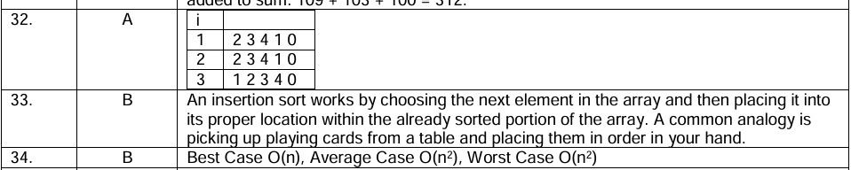Q38: C
2018 Invitational B
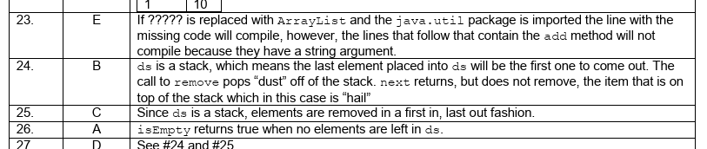Q37: E
2018 District
